Redistricting Web App Guide
Table of Contents
Section 1 Intro………………Page 1
Section 2 Guidelines……..Page 1
Section 3 Logging In………Page 2
Section 4 Web App………..Page 3
Section 5 Layer List…………Page 11
Section 6 Exporting Council District Layer……Page 14

Section 1 Introduction
This redistricting tool was developed by the Montgomery Planning Department’s ITI division. The tool is only meant to assist the County Commission in creating new council voting districts. It allows Commissioners to work individually and then come to agreements of the shape of Districts at future meetings. You will be given a password protected way to access the GIS application that is located on the Planning Department’s web server. We ask those accounts not be shared so that you have a private place to do your individual homework.
The tool allows you to edit a computer generated map to define the shape of 7 new districts. The tool allows you to see “layers” of data that may or may not influence how to shape your districts. Information on the population for each district, including the racial composition of your defined districts is calculated as you edit your district.
It is best if the application is displayed to the full extent of your screen. It is best viewed on 15+ inch monitors.
If you have any questions that are not covered by this guide or the supplemental video guides, please contact the Redistricting Project GIS Administrator or Council Staff.

Section 2 Guidelines
These are rules set by the County Commission to be followed when creating the new Council Districts.
TO BE DETERMINED IN JUNE

Section 3 Logging In
Logging into the web app is done by following these steps:
- Enter the link sent to you via email by the GIS administrator into your web browser’s search bar.
- Enter your Username in the top blue bar and password in the lower blue bar. See Figure 1.1 below.
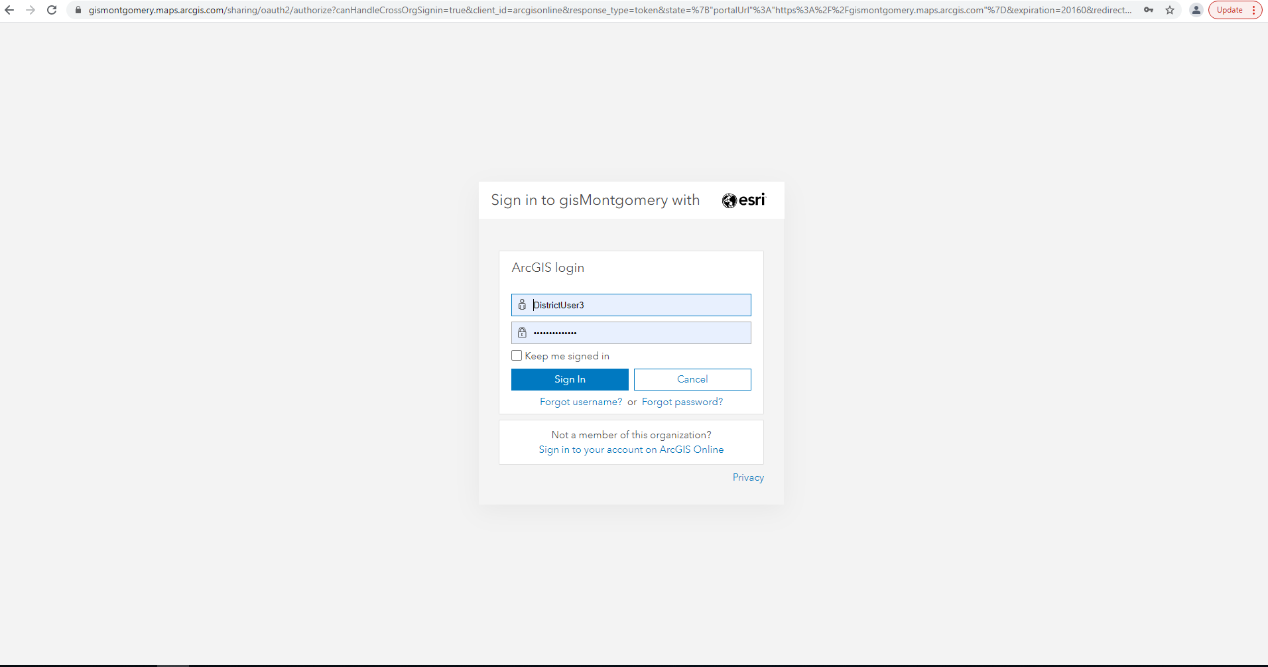
Figure 1.1 Web App Log In screen.

- Click sign in and you will be brought to the Web App Screen see Section 4 for more details.

Section 4 Web App
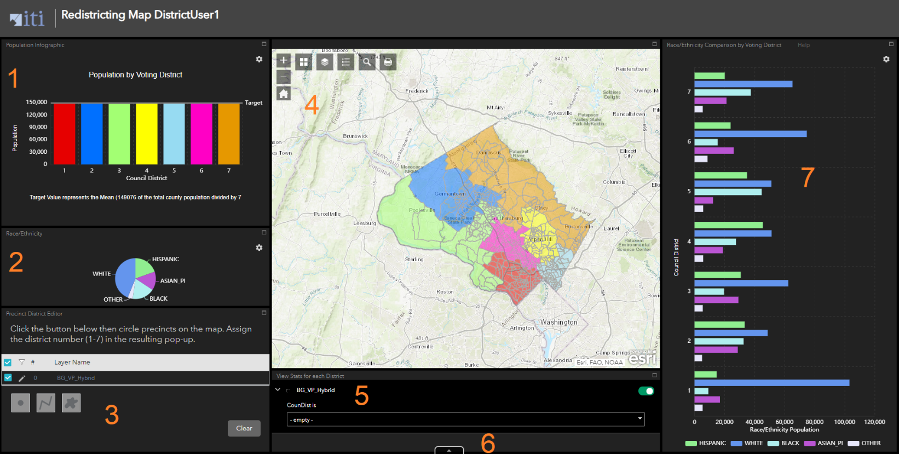
Figure 4.1 Web App Main Page*
*The Council districts shown are for illustration only.
Important Note: Depending on the user screen size some windows of each numbered section may have scroll bars that need to be engaged to see the whole window. Each numbered section window can be enlarged by clicking on the box symbol in the upper righthand corner of the section. This can be reversed by clicking the line in the upper right corner to the same way (this line maybe tricky to see so just click the upper right portion of the window bar). The windows can all be adjusted to your liking by using the left mouse button and dragging the edges of the box with the mouse.

- Population in Districts - Graph
A graph showing the population totals for the Council Districts. The graph starts by showing all districts but adjusts based on the selection of an individual district. (See Section 4.1 for more info.)

- Race/Ethnicity - Pie Chart
A pie chart representing the racial and ethnic summary for the currently selected Council Districts. The graph starts out showing all districts but adjusts based on selection (See Section 4.2 for more info).

- Precinct Editor Tool
The tool which allows for the creation and editing of Council District Boundaries (See Section 4.3 for more info.) There is a scroll bar on the right side of this section. It permits the user to get to the selection tool choice at the end of the section.

- Map Display
The main map display that shows layers and where Council District edits will be made. (See Section 4.4 for more info.)

- District Focus Tool
Allows the user to select a specific Council District (See Section 4.5 for more info.)

- Attribute Table
This tab opens the attribute table for the currently selected map layers. (See Section 4.6 for more info.)
- Race/Ethnicity Bar Graph
This graph displays the Race/Ethnicity Demographics by each district and will adjust according to user selections (See Section 4.7 for more info.)

Please note that you will start out with the entire county as Proposed Council District 1. You will carve out the other council districts from proposed council district 1. The graphs will update as you create new districts. It may work best for you to create 7 large random districts using the freehand polygon tool (See section 4.3) then distribute the block groups from there.

Section 4.1- Population Graph
This graph displays the populations of the Council Districts. When a block group or groups are selected it will display the information for that selection. As selections are made this chart updates in real time. The Target value marked on the graph is the Mean(Average) of the total population of the county divided by 7. The upper and lower range is the mean population plus or minus 5 percent.

Section 4.2- Race/Ethnicity Pie Chart
This Pie Chart shows the Racial and Ethnic demographics of the current selection. By default, this displays the demographics for the whole county. As selections are made this chart updates in real time.
Section 4.3- Precinct Editor Tool
This is the primary tool a user will use to create the districts. You will notice there are checkboxes for the layers. Leave these check boxes alone. Make sure they are checked at all times. There are 3 tools to choose from below the layer list starting from left to right. You may need to scroll down (using the bar on the right) to see these tools.
- The dot tool allows the selection of a single block group.
- The polyline tool will select all block groups the line intersects with. This is best used to select multiple groups near a boarder and is more precise than the free hand polygon tool.
- The last tool is the freehand polygon tool. This tool allows the user to select multiple block groups at once in large batches. It is best used when first creating a new Council District.
- Below the tools is a button marked Clear. Use this to clear a selection that you are unsatisfied with.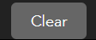
After a selection has been made using one of the above tools the selected block groups will appear transparent and a drop down will appear on the map portion of the app; this will allow the user to assign a new district. (You may need to adjust your view of the map to see the selection box.) Select a number 1-7 from the drop down. Once a district has been chosen, click the save button to change the selected block groups to the chosen district number. The graphs and map will update according to the user’s selection. After a selection is changed or cleared the tool buttons will need to be clicked on again to start a new selection.

Section 4.4- Map Display
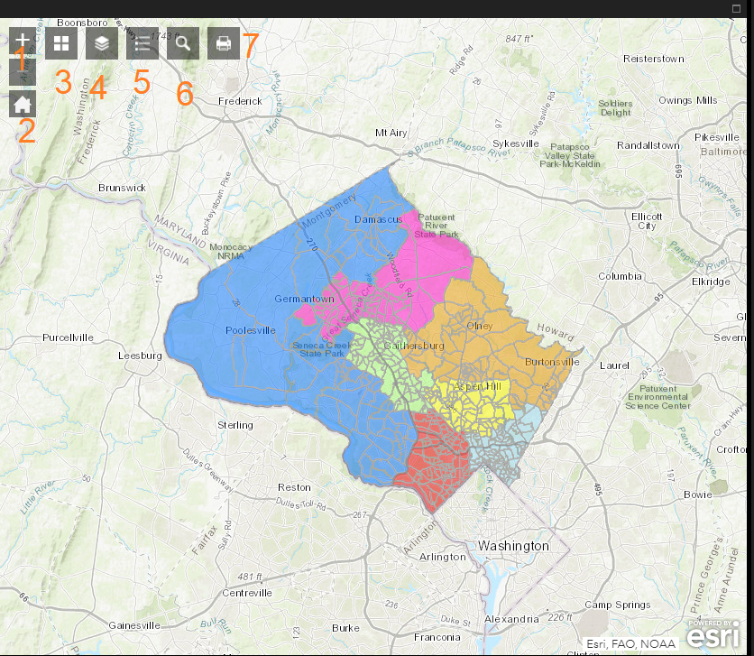
Figure 4.2 Map Display with tools numbered.
The map is where block group selections will be made. In addition, there are several tool buttons in the upper left corner the Map Display.
- The + and – buttons zoom in and out respectively on the current display.
- The button with a house returns to the original zoom and perspective as when the web page first loaded up.
- The button with 4 squares is the basemap tool. Here you can select from a variety of basemaps. The basemap is the bottom most layer that all the other layers appear on top of. By default, the Topographic basemap is selected.
- To the right of the basemap is the Layer List tool (See Section 5 for more information) represented by a button with 3 stacked squares. This is where layers can be turned on and off. To turn on a layer simply click the checkbox next to its name. To turn it off uncheck the box. To the left of the checkbox is a small arrow these can be clicked to show the symbology for that corresponding layer. To the right of the layer name are 3 dots (See Figure 4.3). This will be important for exporting your data (for more information please see the section on exporting data). There are multiple items under these 3 dots :
- Zoom to- Zooms the map display to show the entire layer.
- Transparency- Opens a slider that lets the user change the transparency of the layer.
- Set visibility range- Is used to set at which zoom levels the layer appears (It is not advisable to alter these settings).
- Disable pop-up- Turns off the pop-up window for the layer (Do not alter the default settings)
- Move up/Move down- These allow the layer order to be changed on the map. This is a useful tool if you want to see one particular layer on top of all the others.
- View in Attribute Table- Opens the metadata for the layer in the attribute table (see section 5.6 for more information).
- Show item details- Very important. Used to export the shapefile or layer. (See Exporting Council District Layer for more information).
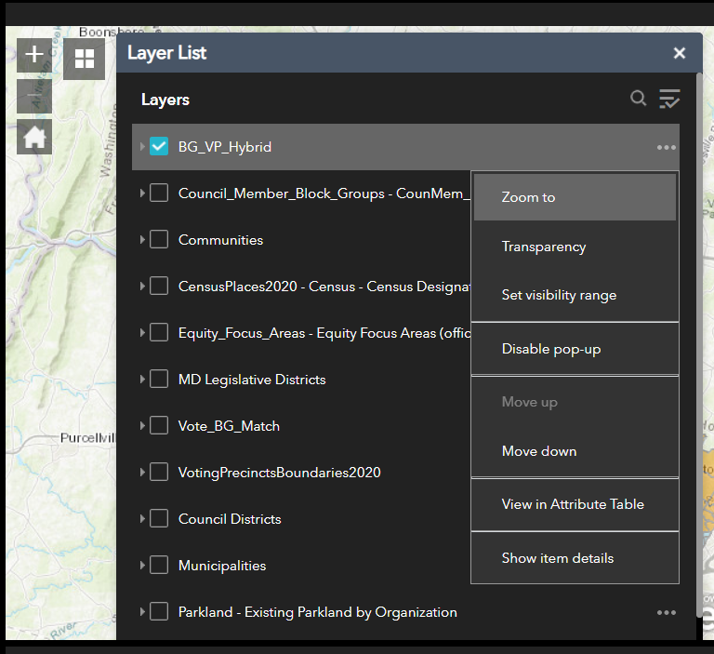
Figure 4.3 Detailed Layer View after the 3 dots have been clicked.

- The button with lines and shapes to the right of the layer list is just a simple legend of the symbology for the currently active layers.
- The button with a magnifying glass is the search tool. With it a user can search for specific addresses or places.
- The button with the printer icon is used to print out the map portion of the web app.
Section 4.5- District Focus Tool
Allows users to select a particular district and see the graphs and statistics for that district alone. By default, the tool is set to on when the page loads. DO NOT toggle the green switch in the upper right corner of the tool. To use the tool simply click on the drop-down bar on the bottom of the tool and select a district. To reset to all districts simply select “empty” from the drop-down menu.
Section 4.6- Attribute Table
This tab brings up the data for the layers in a table. For the council district layer each row represents a block group.

Section 4.7- Race/Ethnicity Bar Graph
A bar graph showing the racial/ethnic demographics for each district. The color codes match the pie chart from section 4.2. This graph will update in real time based on the changes made to the council district layer and if the District Focus Tool is being used only one district’s bars will be shown.
Section 4.8- Select Tool
The Select tool is located on a tab to the right of the View Stats for each District tool. This tool works in a similar fashion to the Precinct Editor tool (see section 4.3). This tool allows you to select multiple block groups and see the data in the population charts for those specific block groups. This is a handy way to find out percentages and population distributions before using the precinct editor. The tools in this are the same as the Precinct Editor some with different names. The point tool selects one block group at a time. By holding shift and left clicking on another block group you can add to your selection. The select by line works like the polyline tool in the Precinct Editor. The lasso works the same as the Precinct Editor Freehand Polygon tool. When you are ready to move on to another tool or make an entirely new selection click on the “Clear” Button on the right. See figure below.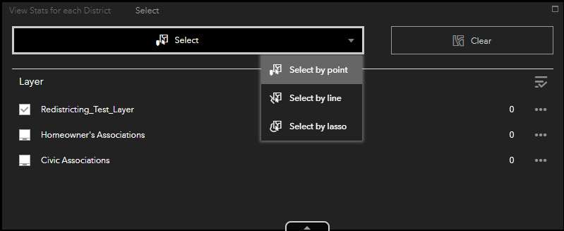
Figure 4.4 Select Tool Menu
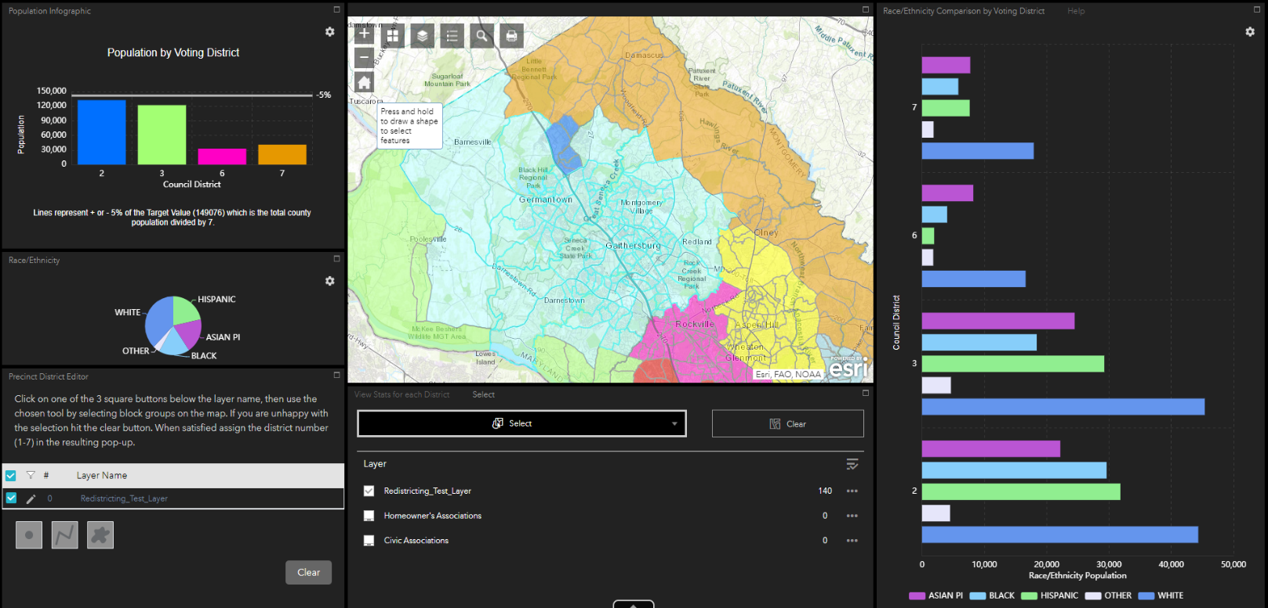
Figure 4.5 Select tool results. Note how the graphs only display the districts involved in the selection and only the data for those specific block groups within the districts. Selected block groups have a cyan blue border and highlight.

Section 5 Layer List
Here you can find information about the various layers that are used on the map display (Section 4.4).

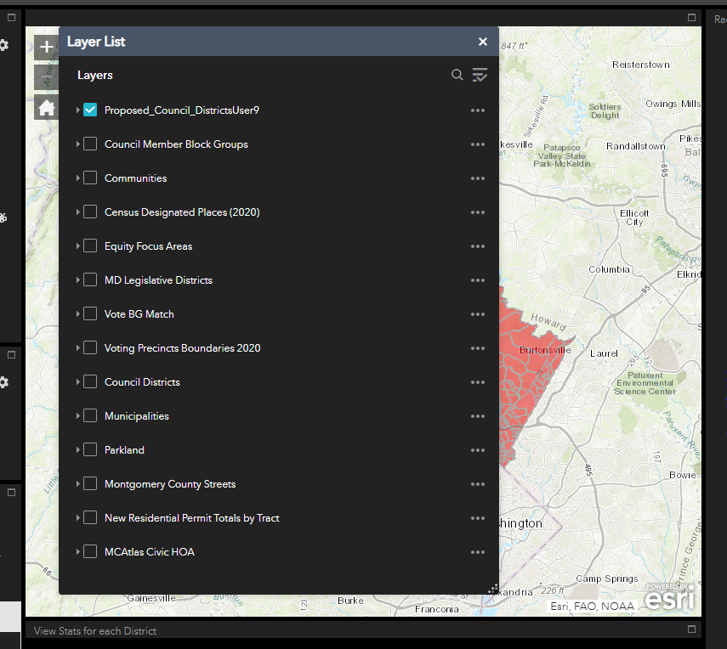
Figure 5.1 The Current Layer List

- Proposed Council Districts Layer
This is the layer the user will be editing to create the new preliminary Council Districts

- Council Member Block Groups
These are the areas where current council members reside. These Block Groups cannot be changed.

- Communities
A boundary layer showing the communities of the county. For example, Germantown, Bethesda, Montgomery Village, etc.

- Census Designated Places (2020)
This layer represents Census-designated places (CDPs) which, are communities that lack separate municipal governments, and for statistical purposes are defined by the Census Bureau to statistically combine and compare populated areas that physically resemble incorporated places.

- Equity Focus Areas
A layer based on simple analysis of 3 core equity variables to define the highest concentration of vulnerable populations. EFA are derived from high concentrations of low-income households, people of color, and people speaking English less than very well. EFA analysis is a dichotomy: tracts are either designated an EFA or not.

- MD Legislative Districts
A boundary layer depicting the geographic areas for the County’s Senators and Delegates to the Maryland General Assembly within Montgomery County.

- Vote BG Match
This layer references where block groups match up perfectly with the 2020 Voting Precinct Boundaries.

- Voting Precincts Boundaries 2020
These are the boundaries that the new Council Districts will eventually conform to. Currently we are using block groups because the metadata containing population information will not be available for this layer until September of 2021.

- Council Districts
This layer contains the boundaries for the current 5 Council Districts.

- Municipalities
A polygon layer marking the location of officially established municipalities in the county. Note are the Gaithersburg and Rockville municipalities, which are quite large and border one another.

- Parkland
A polygon layer displaying the existing parkland in the County. Stream Valley Parks are natural barriers between communities.

- Montgomery County Streets
A more detailed layer for the streets within the county if the user finds the basemap information insufficient.
- New Residential Permit Totals by Tract
A count of Residential Construction Permits by Census Tracts 2010 through May2021. Larger dots indicate more permits.
- MCAtlas Civic HOA
A polygon layer showing the locations of various Civic and Home Owners Associations.

Section 6 Exporting Council District Layer
When the user is satisfied with their new Council District Layer they can export by first clicking the 3 dots as seen in the layer list in Figure 4.3. From here the user should select “Show Item Details”. From this screen the user should select “Export Data” (See Figure 6.1 below) From here the data can be exported in multiple formats. Shapefile and CSV will be used the most. Please contact the GIS Administrator when you would like to back up a scenario and start a new one.

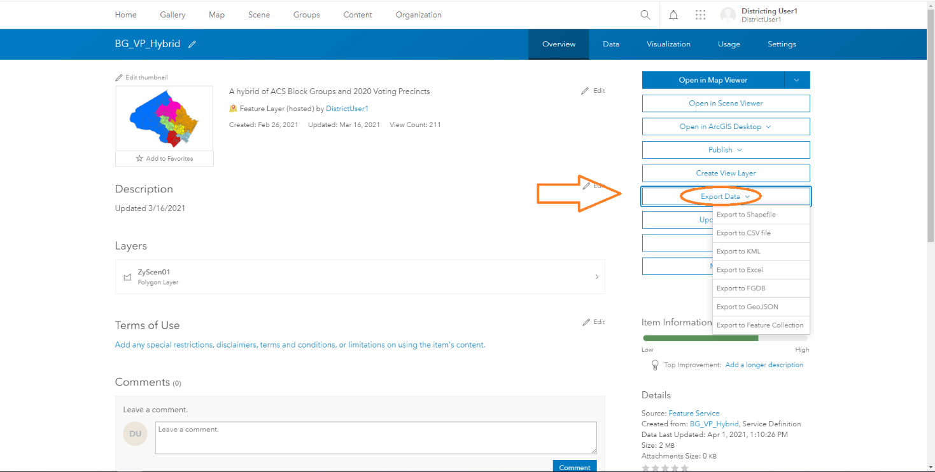
Figure 6.1 Export Data

