Avoca Lane
A Rustic Road
Avoca Lane has outstanding natural features, historic value, and farm vistas leading to a forested stream valley and parkland. This road was designated rustic in the 1997 Cloverly Master Plan.

Recommendations
- Approve the road’s significant features.
When Avoca Lane was designated rustic in 1997, the master plan did not explicitly specify the significant features of the road. The table summarizing the criteria for including it in the program, in addition to showing that the road meets the basic criteria necessary to be designated rustic, noted that the road has outstanding natural features. The master plan describes the road as narrow and mostly straight, with some slight elevation changes in certain locations. The plan indicates that most of the road has complete tree canopy enclosure, which blocks the view of distant locations.
The road has very gentle curves along its length, with frequent embankments along the road’s edges. Combined with the trees close to the road on both sides and the canopy enclosure overhead, Avoca Lane provides a very immersive experience. The narrow stream crossing provides additional character.
- Change designation from rustic to exceptional rustic.
The Rustic Roads Advisory Committee recommends reclassifying this road from rustic to exceptional rustic.
To be classified as an exceptional rustic road, in addition to meeting the criteria for designation as a rustic road, it must be found that the road:
- Contributes significantly to natural, agricultural or historic characteristics.
Avoca Lane provides an immersive traveling experience through the woods and across a small stream.
- Has unusual features found on few other roads in the County.
The gravel road is one of the few remaining in the county, and the road is exceptionally narrow.
- Would be more negatively affected by improvements or modifications to the physical characteristics of the road than would most other roads in the rustic roads program.
Improving the road would detract greatly from its exceptional rustic character.

Significant Features
- Narrow pavement with embankments, including a narrow stream crossing
- Vertical and horizontal alignments
- Wooded on both sides with mature trees and a high canopy
- Views along road and into stream valley

History
Avoca Lane first appears on USGS topographic maps in 1907 as an unimproved road connecting Oak Hill Road to Brogden Road, branching northwest from Batson Road, a connection which disappeared by about 1944.
In the early 20th century, Avoca Lane formed part of a roughly west-to-east route from Ednor Road across the Patuxent. Connections from Oak Hill Road to Ednor Road and from Batson Road across the Patuxent have since been broken but suggest that Avoca Lane served an important connectivity function when first laid out. For the historically African American communities that grew along Batson and Brogden Roads in the 19th and early 20th centuries, Avoca Lane would have provided convenient access to major county thoroughfares to the west. There are no designated historic sites on this road.

Traveling Experience
Avoca Lane is a narrow road traveling east from Oak Hill Road. Entering the road means taking a deep descent into completely forested areas with no homes or structures in view. Proceeding east, the road crosses over a narrow culvert which has been recently replaced with a modernized storm drain structure and a metal railing that is uncharacteristic of a rustic road. The road winds up a hill and passes some residences, then curves under power transmission lines, where a long view to the right shows massive grass plantings descending into a valley. Much of the road has a tree canopy. The public road ends shortly before the power line area.

Environment
This narrow, forested road has a culvert crossing a tributary to Foxes Branch. This high-quality stream flows directly into the Rocky Gorge Reservoir, which is surrounded by the T. Howard Duckett Watershed, managed by WSSC. This reservoir and the Triadelphia Reservoir just upstream provide drinking water for approximately 600,000 customers primarily in eastern Montgomery and northern Prince George’s Counites.

Road Characteristics
Extents | Entire road: Oak Hill Road to end of county maintenance
Length | 0.22 miles
Width | 17 feet
Surface | Paved
Lanes | No centerline or edge markings
Shoulders | None

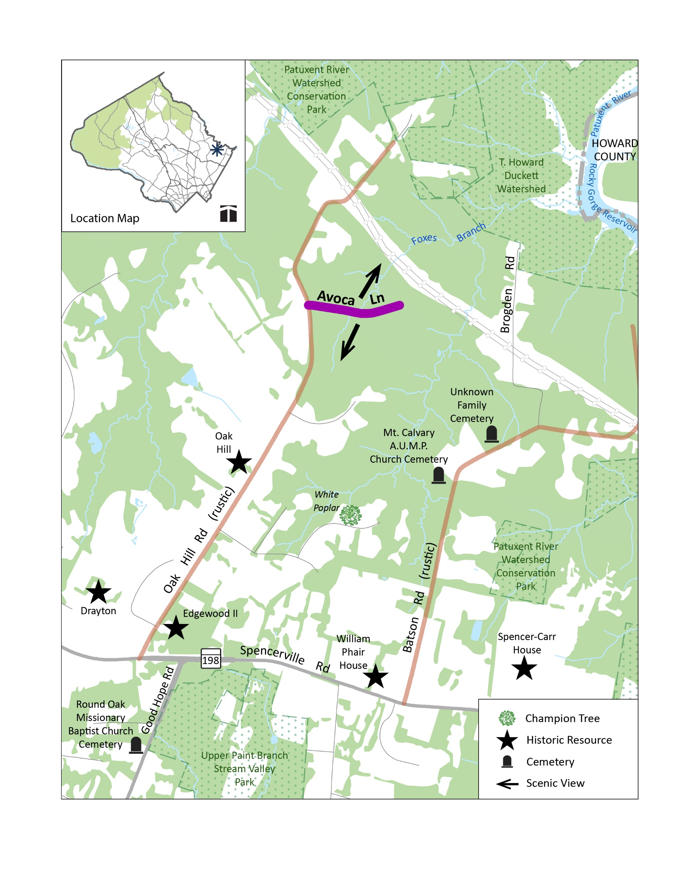
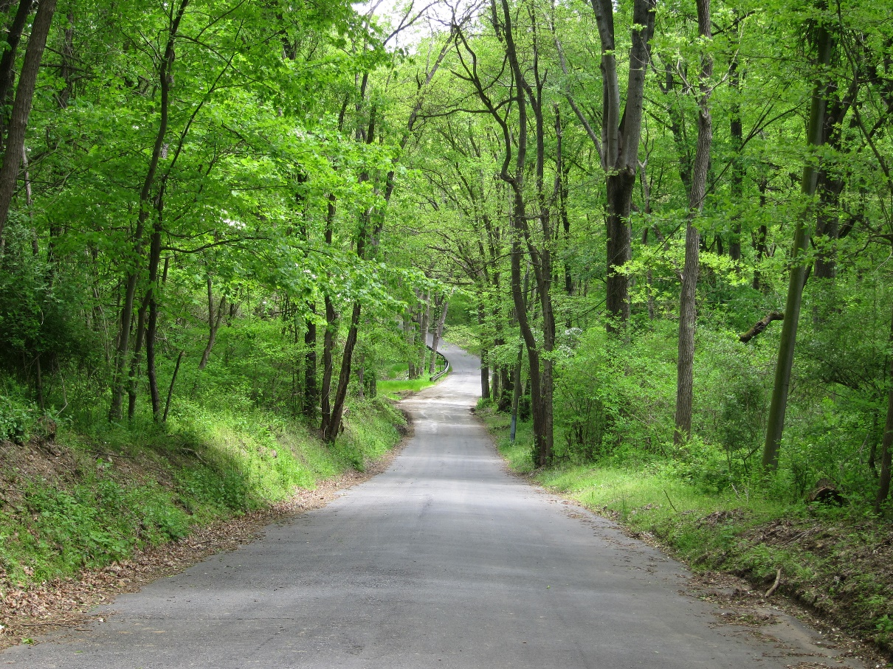
View looking east on Avoca Lane
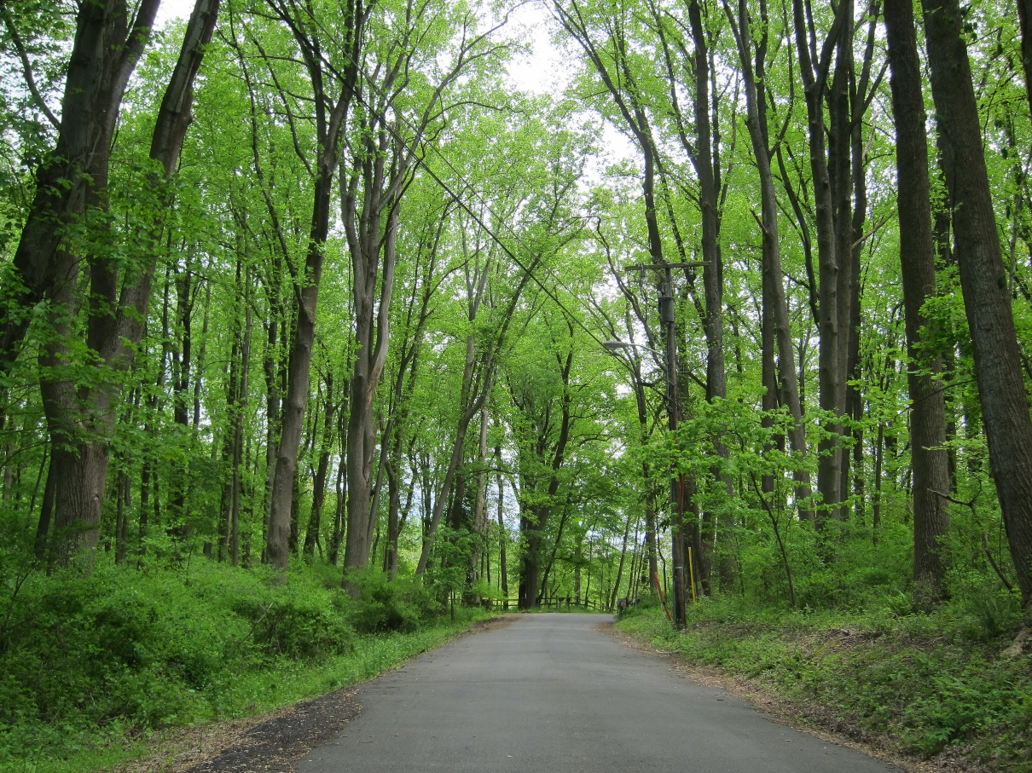
View looking east toward property with split-rail fencing in distance

