SSL For Tomcat.

Certificates
- For IIS we use .pfx files and this must be supplied by the customer.
- For Tomcat we require a p7b certificate and if it is not received from the customer, you can create own.
- Launch IIS and select the server name, then Server Certificates.
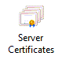
- Right-click on the certificate and select Export.
- Export the .pfx file to the root of the drive where ProjectDox resides, choose a password and confirm the password. You will need this password during the Tomcat SSL process.
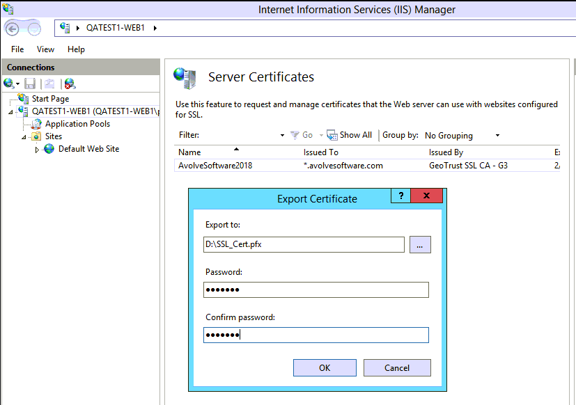
- Launch the mmc.exe on the web server.
- Choose File, Add/Remove Snap-in and choose Certificates.
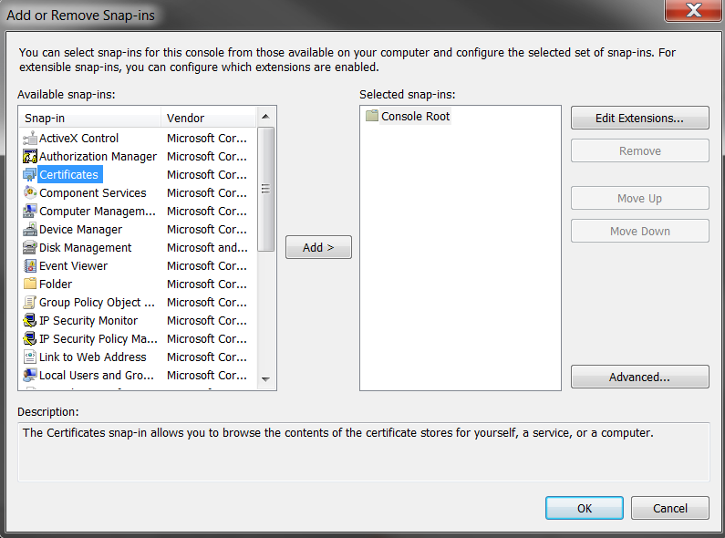
- Click the Add button in the middle of the screen.
- Choose the third radio button, Computer account then click Next.
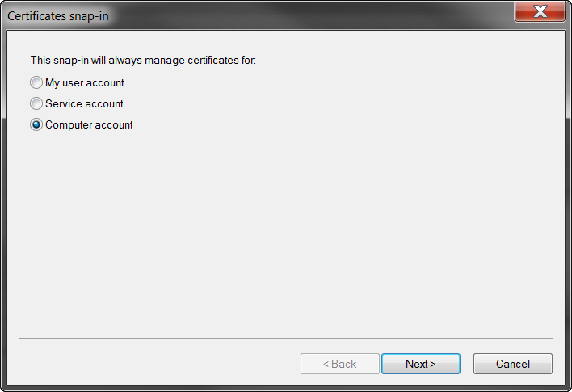
- Continue with the default radio, Local computer (the computer this console is running on), then click Finish.
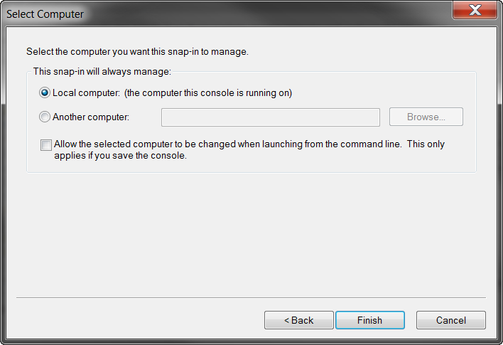
- Expand Personal, select Certificate, right mouse click on the certificate.
- Choose All Tasks, Export.
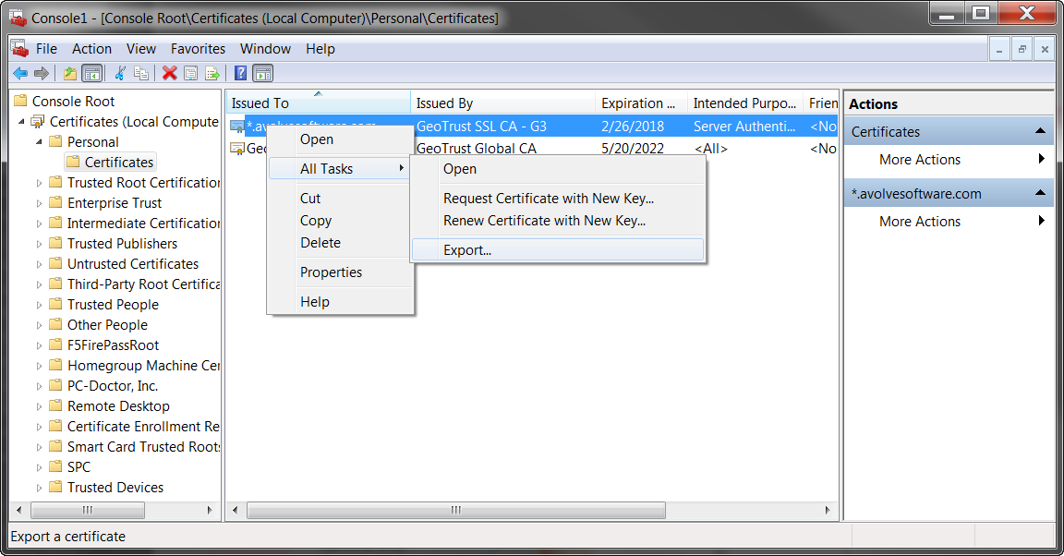
- Click Next on the Welcome to the Certificate Export Wizard.
- Click the radio for Cryptographic Message Syntax Standard for PKCS #7 Certificates (.P7B)
- Place a checkmark for Include all certificates in the certification path if possible, click Next.
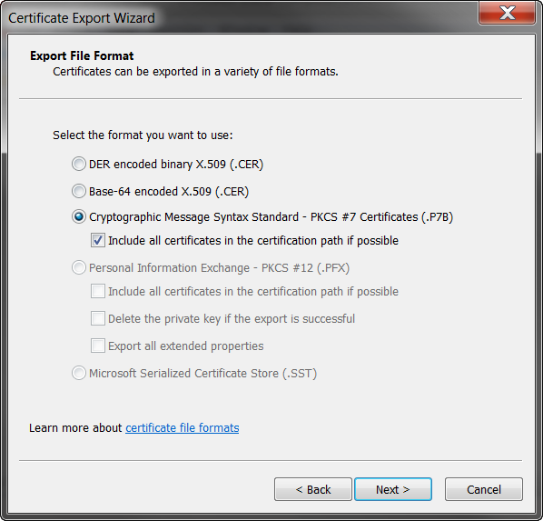
- Use the Browse button and navigate to the root drive where ProjectDox is installed and save the file as a .p7b file.
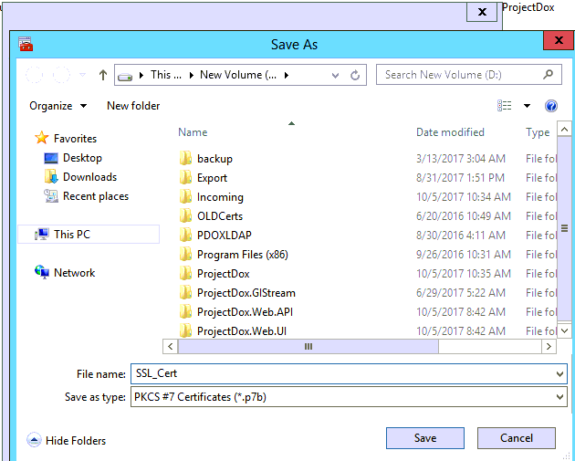
- You will be returned to the File name screen, click Next.
- Once the process is complete, you will see the settings you specified, click Finish.
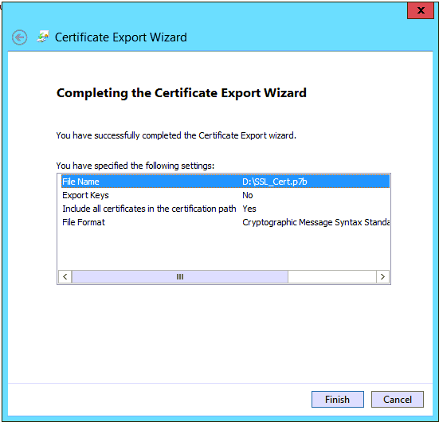
You now have a .pfx with a known password and a .p7b certificate to continue on to the next step.

Installation DOS Commands

Create the Keystore for Tomcat
- Convert .pfx certificate file to JKS:
  - Launch a command prompt on the web server.
  - From Java folder (eg. C:\Program Files\Java\jre7\bin) run the following command:
Sample: keytool -importkeystore -srckeystore e:\certificate.pfx -srcstoretype pkcs12 -destkeystore destcert.jks -deststoretype JKS -storepass <yourpassword>
Actual: keytool -importkeystore -srckeystore e:\incoming\lorassl\avolvecloudsslcom.pfx -srcstoretype pkcs12 -destkeystore pdtomcert.jks -deststoretype JKS -storepass MyPassword
The result will give you the keyAlias value.
Entry for alias le-c5a08b67-625c-4184-8769-59eca73b6b55 successfully imported.
Import command completed: 1 entries successfully imported, 0 entries failed or
cancelled
In the above command, we did not provide a path for the –destkeystore parameter therefore, the JKS file is created in Java bin folder.
- Copy the C:\Program Files\IGC\Tomcat 8 For Brava\conf\your_p7b_file.p7b into C:\Program Files\Java\jre7\bin.
- Import certificate into JKS file (which is the keystore) using this command:
Sample: keytool -import -trustcacerts -alias alias_from_jks_file -file your_p7b_file.p7b -keystore destcert.jks -storepass <yourpassword>
Actual: keytool -import -trustcacerts -alias le-c5a08b67-625c-4184-8769-59eca73b6b55 -file ssl_certificate.p7b -keystore pdtomcert.jks -storepass <yourpassword>
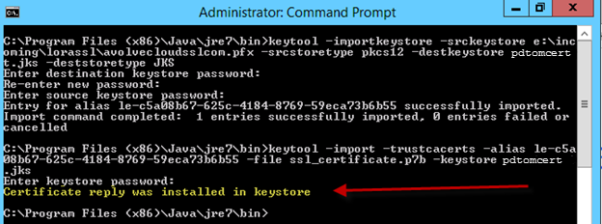

Edit server.xml
- Copy destination JKS file to C:\Program Files\IGC\Tomcat 8 For Brava\conf folder.
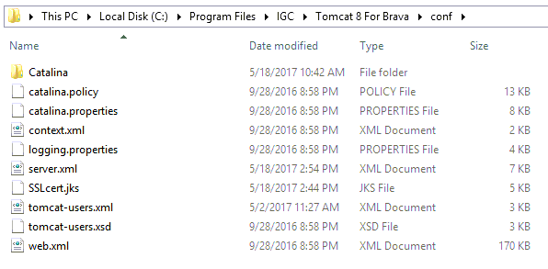
- Before changes are made to the server.xml file, save the original file as server.xmlOrig.
  - If for any reason you need to revert to non SSL, activating the original file will make it very easy.
- Edit C:\Program Files\IGC\Tomcat 8 For Brava\conf\server.xml file. You can skip a-d if you copy the server.xml file from \ProjectDox\Integration\BravaPlugin\JP folder and edit the following 2 values, this example is configured for SSL.
keystorePass="<<KEYSTOREPASSWORD>>"
keyAlias="<<KEYALIAS>>"
  - Uncomment the following section:
<Connector port="8443" protocol="org.apache.coyote.http11.Http11NioProtocol"
maxThreads="150" SSLEnabled="true" scheme="https" secure="true"
clientAuth="false" sslProtocol="TLS" />
  - Update Tomcat to use newer TLS protocols by replacing sslProtocol=”TLS” with
sslEnabledProtocols="TLSv1, TLSv1.1, TLSv1.2"
  - Add new keys to that section:
<Connector port="8443" protocol="org.apache.coyote.http11.Http11NioProtocol"
maxThreads="150" SSLEnabled="true" scheme="https" secure="true"
clientAuth="false" sslEnabledProtocols="TLSv1, TLSv1.1, TLSv1.2"
keystoreFile="${catalina.base}/conf/pdtomcert.jks"
keystorePass=”XXXXXXXXXX”
keyAlias=”XXXXXXXXXXXXXXXXXXXX”
ciphers="TLS_ECDHE_RSA_WITH_AES_128_CBC_SHA256,
TLS_ECDHE_RSA_WITH_AES_128_CBC_SHA,
TLS_ECDHE_RSA_WITH_AES_256_CBC_SHA384,
TLS_ECDHE_RSA_WITH_AES_256_CBC_SHA,
TLS_ECDHE_RSA_WITH_RC4_128_SHA,
TLS_RSA_WITH_AES_128_CBC_SHA256,
TLS_RSA_WITH_AES_128_CBC_SHA,
TLS_RSA_WITH_AES_256_CBC_SHA256,
TLS_RSA_WITH_AES_256_CBC_SHA,
SSL_RSA_WITH_RC4_128_SHA"
/>
  - To turn off the logs in Tomcat that create excessive large files named localhost_access_log, comment out the following line:
<Valve className=”org.apache.catalina.valves.AccessLogValve” directory=”logs” prefix=”localhost_access_log.” Suffix=”.txt” pattern=”%h %l %u %t &quot;%r&quot; %s %b” />
  - Save the server.xml file.

