**HISTORIC PRESERVATION COMMISSION STAFF REPORT**

**Address:** 715 Pershing Dr., Silver Spring **Meeting Date:** 9/5/18

**Resource:** Riggs-Thomson House **Report Date:** 8/29/18

**Individually Listed Master Plan Site**

**Review:** HAWP **Public Notice:** 8/22/18

**Case Number:** 36/08-18A **Tax Credit:** Yes

**Applicant:** Sam Fleming **Staff:** Dan Bruechert

**Proposal:** Siding, windows and porch repair, and storm window installation

**STAFF RECOMMENDATION:**

Staff recommends that the HPC **approve with one (1) condition** the HAWP application:

1. The historic fabric needs to be retained to the greatest extent possible. The approval of this HAWP does not extend to the removal and replacement of the siding, trim, soffits, cornices, and other materials proposed to be “repaired and/or replaced.” The replacement of these materials is contingent on Staff’s finding that the material has deteriorated beyond repair. In order to make this finding, the applicant needs to arrange a time for Staff to field verify the condition of the individual elements prior to the approval and stamping of permit drawings.

# PROJECT DESCRIPTION

SIGNIFICANCE: Master Plan Site (Riggs-Thomson House)

##### STYLE: Italianate/Second Empire

DATE: c.1858; 1866

From *Places from the Past*:

“George Washington Riggs was the founder of what became Riggs National Bank and one of Washington, D.C.’s wealthiest and most influential citizens. He and his wife Janet Sheddden established a 140-acre country estate in Silver Spring about 1858. Their brick Second Empire style residence forms the central core of the present structure. George and Janet Riggs’ previous summer estate had been a Gothic Revival cottage they built in 1842. That residence still stands and is known as the Anderson Cottage, at the US. Soldier’s and Airmen’s Home. At the height of the Civil War, when soldiers were torching and plundering Silver Spring houses, the Riggs’ sold their property and moved to safer territory in Green Hill, Prince George’s County. William H. Thompson, locally prominent businessman and social leader, expanded the house about 1866, creating an Italianate-style estate. A contemporary account described the home of Thompson and his wife, Helen Nourse as “an elegant residence attractively located in the center of choice land… and containing fine forest, beautiful drives and lawns.” Under the tremendous demand for houses in the early 20th century, the large estate was developed, in 1924 and 1931, into residential subdivisions. Since 1933, the Riggs-Thompson House on its remaining property served educational purposes, as the long-time Holy Names Academy and Convent, and more recently, the Chelsea School.”

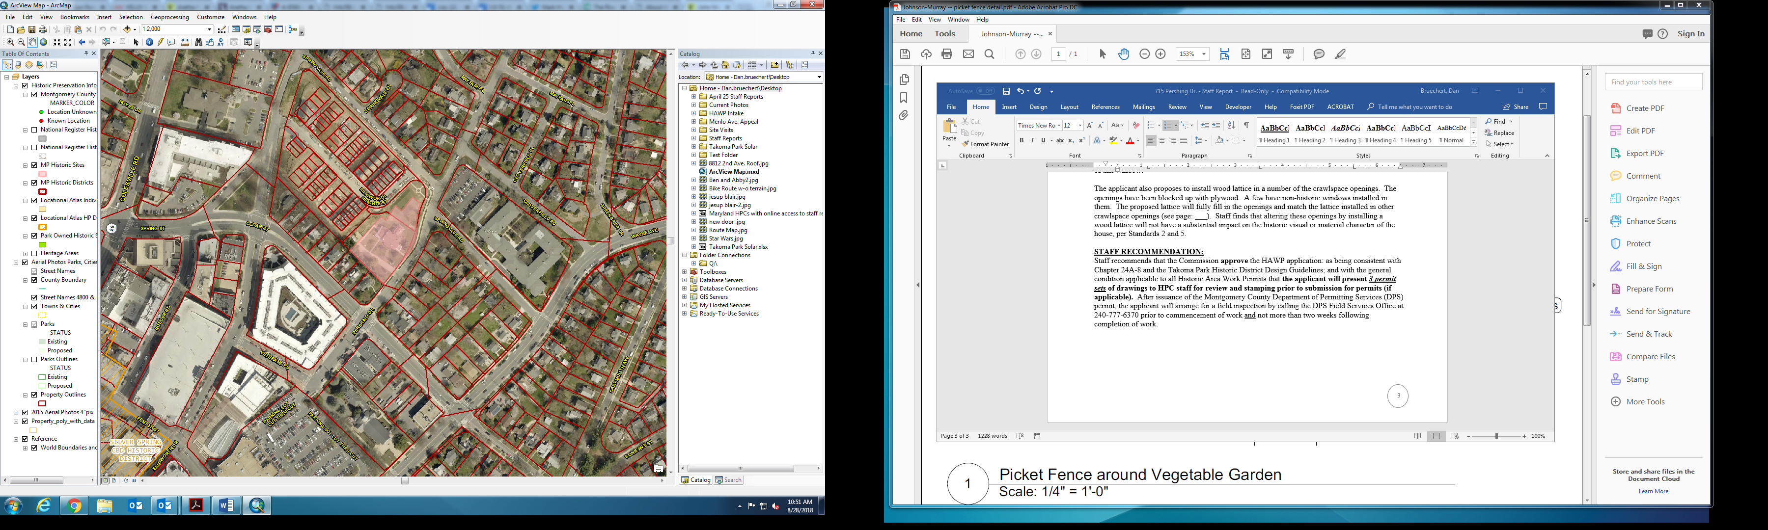

Figure 1: The Riggs-Thompson House is located at the shaded parcel in the middle of the map.

**PROPOSAL**

Much of the work proposed is repair in nature. The applicant proposes to repair:

* Exterior wood stairs and railings and
* Exterior siding and trim

The applicant also proposes to:

* Remove the existing siding from a historic addition and installing sheathing and reinstalling the siding;
* Install storm windows; and
* Install lattice in existing crawlspace openings.

**APPLICABLE GUIDELINES:**

When reviewing alterations and additions to a *Master Plan* site several documents are to be utilized and guidelines to assist the Commission in developing their decision. These documents include Montgomery County Code chapter 24A (Chapter 24A) and the *Secretary of the Interior’s Standards for Rehabilitation* (*Standards*) and can be guided by the details in the Design Guidelines for Historic Sites and Districts in Montgomery County, Maryland (*Design Guidelines*). The pertinent information in these documents is outlined below.

*Secretary of the Interior’s Standards for Rehabilitation*

1. The historic character of a property will be retained and preserved. The removal of distinctive materials or alteration of features, space and spatial relationships that characterize a property will be avoided.
2. Each property shall be recognized as a physical record of its time, place and use. Changes to a property that has acquired historic significance in their own right will be retained and preserved.
3. Distinctive materials, features, finishes and construction techniques or examples of craftsmanship that characterize a property will be preserved.
4. Deteriorated historic features will be repaired rather than replaced. Where the severity of deterioration requires replacement of a distinctive feature, the new feature will match the old in design, color, texture, and, where possible, materials. Replacement of missing features will be substantiated by documentary and physical evidence.

Montgomery County Code; Chapter 24A-8(b)

A HAWP permit should be issued if the Commission finds that:

1. The proposal will not substantially alter the exterior features of a historic site or historic resource within a historic district.
2. The proposal is compatible in character and nature with the historical archaeological, architectural or cultural features of the historic site or the historic district in which a historic resource is located and would not be detrimental thereto of to the achievement of the purposes of this chapter.
3. The proposal would enhance or aid in the protection, preservation and public or private utilization of the historic site or historic resource located within an historic district in a manner compatible with the historical, archeological, architectural or cultural value of the historic site or historic district in which an historic resource is located; or

**STAFF DISCUSSION**

The work proposed generally falls into two categories, repair and replace in-kind and new features.

**In-Kind Repairs**

The applicant proposes to conduct repairs of exterior siding and trim; exterior stairs, railing, and architectural elements; and the installation of sheathing beneath and reinstallation of the existing siding. Staff’s site visit confirmed the need to repair and replace some of these elements. The applicant proposes to use either mahogany or yellow pine as a replacement material in matching dimensions. Staff finds that the proposal and materials generally comply with Standards 2 and 5; and Chapter 24A(b)(1). Staff finds that the porches are not in their historic configuration and that the porches are not historic. Staff supports the in-kind replacement of the porch members.

The applicant’s proposal does not identify the extent of the siding, trim, soffits, cornices, and other materials to be replaced. As this is an individually listed Master Plan site, Staff recommends that historic fabric be retained to the greatest extent possible. Staff recommends the HPC approve the proposed in-kind replacement work, with the added condition that the replacement of these materials is contingent on Staff’s finding that the material has deteriorated beyond repair.  In order to make this finding, the applicant needs to arrange a time for Staff to field-verify the condition of the individual elements prior to the approval and stamping of permit drawings

**New Work**

The applicant proposes to add storm windows on all windows and to cover some crawlspace openings with wood lattice inserts.

Installing storm windows to preserve historic wood windows is a historic preservation best practice and is encouraged. The applicant proposes to install 46 (forty-six) aluminum, pre-finished, storm windows to be installed within the historic window openings. All of the proposed storm windows will have a muntin bar that aligns with the historic window meeting rail. Staff finds that this is an appropriate storm window (per Standard 5) and supports approval of this window.

The applicant also proposes to install wood lattice in a number of the crawlspace openings. Much of the crawlspace appears to be conditioned space that historically was unoccupied space that had louvered vents in the openings. These openings have been blocked up with plywood and a few have non-historic windows installed in them. The proposed lattice will fully fill in the openings and match the lattice installed in other crawlspace openings (see page: ___). Staff finds that altering these openings by installing a wood lattice will not have a substantial impact on the historic visual or material character of the house, per Standards 2 and 5.

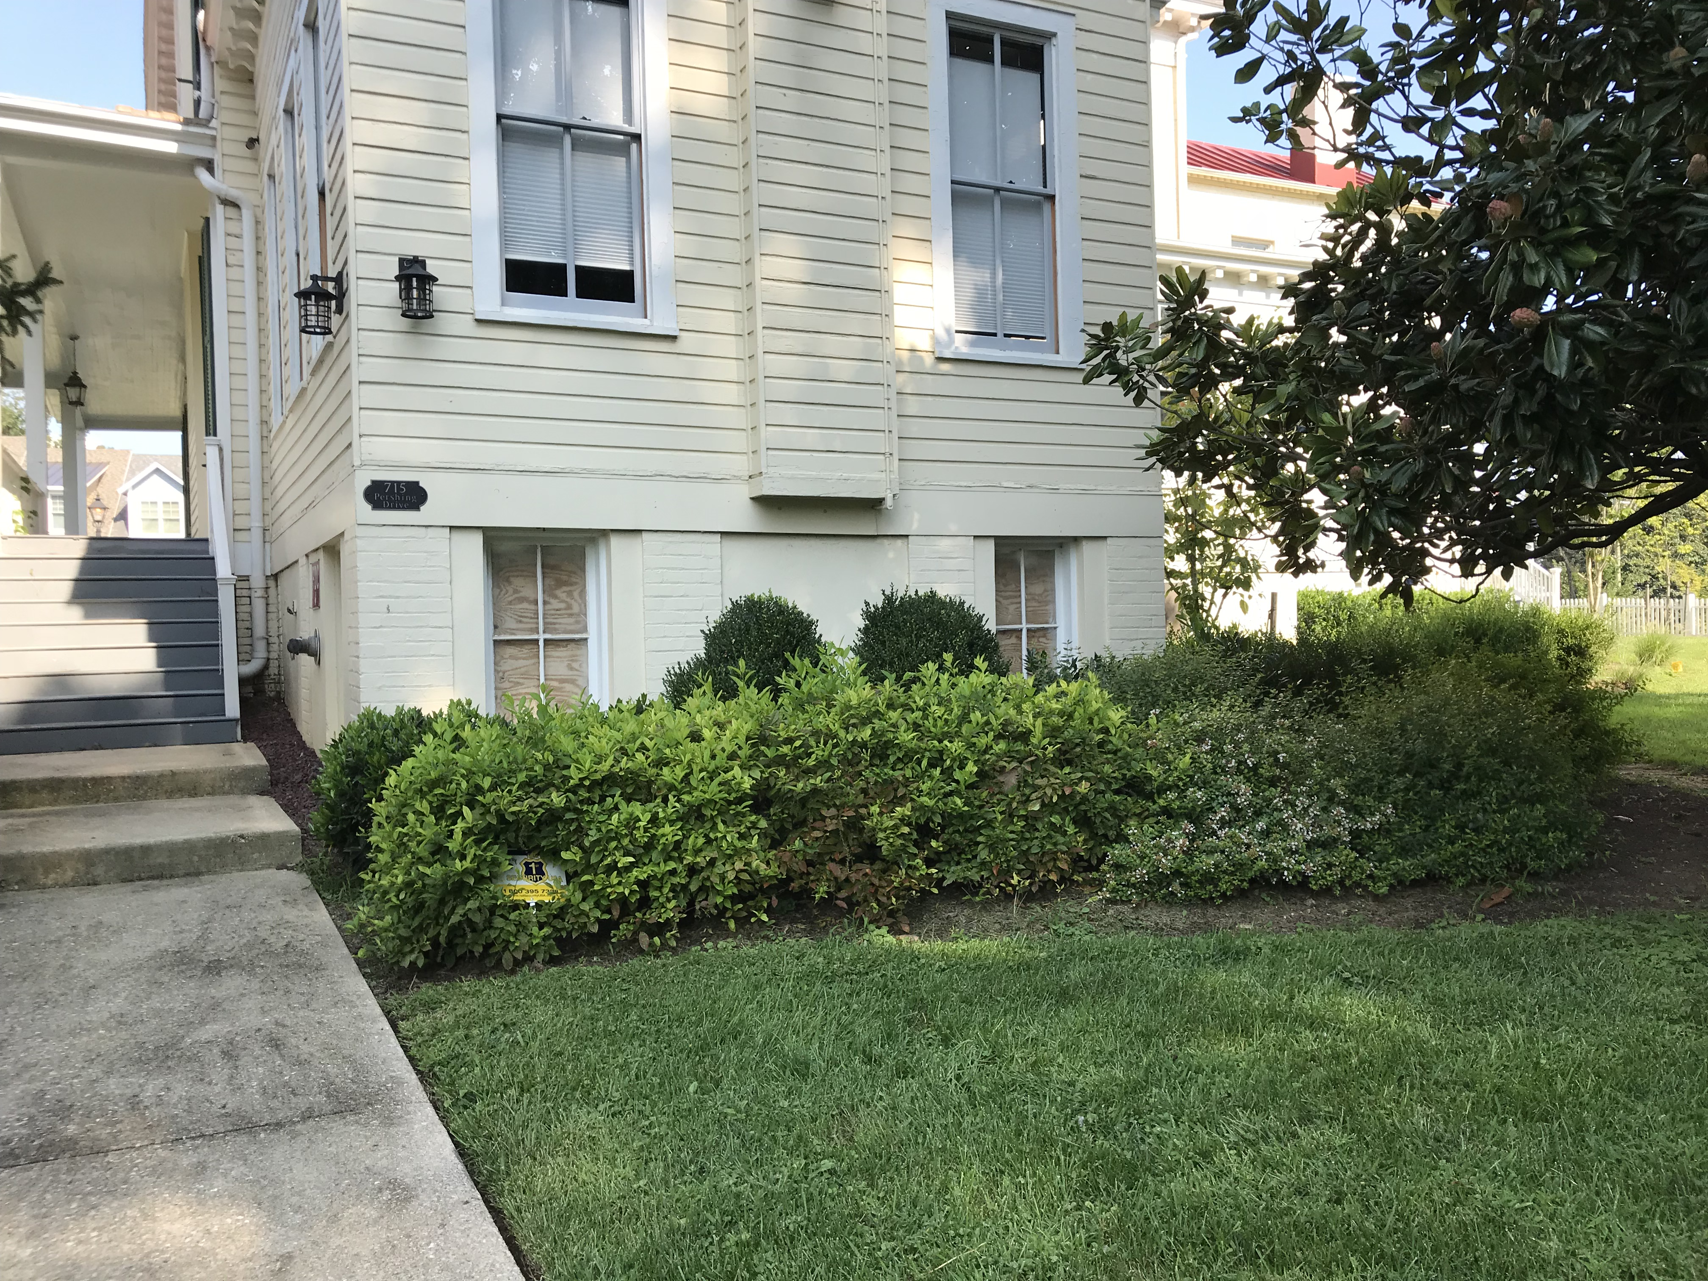

Figure 2: Crawlspace in the historic massing of the house showing the non-historic windows with the plywood behind.

**STAFF RECOMMENDATION:**

Staff recommends that the Commission **approve with one (1) condition** the HAWP application:

The historic fabric needs to be retained to the greatest extent possible.  The approval of this HAWP does not extend to the removal and replacement of the siding, trim, soffits, cornices, and other materials proposed to be “repaired and/or replaced.”  The replacement of these materials is contingent on Staff’s finding that the material has deteriorated beyond repair.  In order to make this finding, the applicant needs to arrange a time for Staff to field verify the condition of the individual elements prior to the approval and stamping of permit drawings;

as being consistent with Chapter 24A-8 and the Secretary of the Interior’s Standards for Rehabilitation; and with the general condition applicable to all Historic Area Work Permits that **the applicant will present *3 permit sets* of drawings to HPC staff for review and stamping prior to submission for permits (if applicable).**  After issuance of the Montgomery County Department of Permitting Services (DPS) permit, the applicant will arrange for a field inspection by calling the DPS Field Services Office at 240-777-6370 prior to commencement of work and not more than two weeks following completion of work.